Supplimentary Figure: Detection of alkaloids (orange band) in in vitro cultured tissue
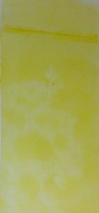
Orange band

